|  |  |
| --- | --- |
|  | Uniform policy |
|  |  |
|  |  |

Version Control

|  |  |  |  |
| --- | --- | --- | --- |
| Reviewer / owner (role) | Executive lead (role) | Approving body | Meeting date when the policy was approved |
| Executive principal | CEO and Executive   Board | Trust board | Email September 2024 |
|  |  |  |  |
|  |  |  |  |
|  |  |  |  |

This policy is reviewed annually / every two years / every three years.  
  
The next review is due by

|  |  |
| --- | --- |
| **Introduction** | |
| The Trust intends and expects that all decisions, policies and procedures will be underpinned at all times by its vision and values. | |
|  | **Our aim**: To create centres of educational excellence that inspire all pupils to turn their potential into performance.  **To achieve this our schools will**:   * Provide a broad and balanced curriculum that allows pupils to develop their talents and ambitions. * Deliver the highest quality learning opportunities facilitated by excellent teachers. * Inspire our pupils to become confident, motivated and respectful individuals ready to make a positive contribution to society.   **The Trust will support our schools by**:   * Maximising the resources and expertise available to individual schools. * Providing a platform for the sharing of excellent practice. * Challenging and developing staff to turn their potential into performance. |

**Uniform and Presentation at The Deanery CE Academy**

Uniform is an important part of the Deanery CE Academy; it is distinctive, innovative and aspirational. The uniform has been designed to be comfortable to wear, smart looking and practical.

Students will present themselves in a professional and smart way at all times; on the way to the academy, during the day and on their way home.

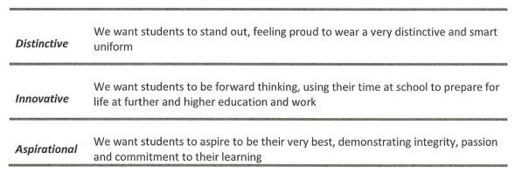

**School uniform**

|  |  |  |
| --- | --- | --- |
| **Item** | **Supplier** | **Notes** |
| Branded Blazer | Trutex | A compulsory piece of uniform; it must be worn every day, throughout the day. In extremely hot weather, the headteacher may decide blazers can be removed. |
| White shirt | Any | White, buttoned collard shirt (can be short sleeved). To be tucked in. |
| Tie | Trutex | A compulsory piece of uniform |
| Purple jumper | Any | An optional piece of uniform. |
| Trousers | Any | Must be charcoal grey, straight legged trousers. Skinny trousers, jeans and leggings are not acceptable. |
| Skirt | Trutex | Must be worn at an appropriate length for school |
| Shorts | Any | Optional, tailored grey knee-length |

**PE kit**

|  |  |  |
| --- | --- | --- |
| **Item** | **Supplier** | **Notes** |
| Branded polo shirt | Trutex |  |
| Branded reversible top | Trutex |  |
| Shorts/Skorts | Any | Plain black and of an appropriate length for school |
| Joggers | Any | Plain black |
| PE socks | Any | Plain black and knee high socks |
| Trainers | Any |  |
| Boots | Any | Students will be advised at the start of each term if these are required |
| Mouthguard |
| Shin Pads |
| Base layers (top and bottoms) | Any | Optional, must be plain back and worn under the uniform as described above |

**Further guidance**

* Jewellery may only consist of a watch and 1 pair of stud earrings (in the earlobes only). No other piercings, including nose piercings, are permitted. Clear nose studs are acceptable. Bracelets and necklaces are not permitted.
* Nail polish, false nails and acrylics are not permitted.
* Hair should be of a natural colour and not extremely styled.
* Belts must be grey or black.
* Make up should be subtle and natural. False eyelashes are not permitted.
* Recognised religious symbols will be permitted but should be worn discretely. Hijabs and turbans should be plain and in school colours (black, grey, purple, white)
* Shoes should be plain black and leather (or leather look) shoes. Heels more than 2.5cm are not allowed; canvas shoes, boots, or sandals are not permitted. Trainers are not acceptable.

